FreelanceHub – Freelance Marketplace Platform.

INTRODUCTION:

Welcome to our freelance marketplace platform FreelanceHub — where clients and skilled freelancers connect in a transparent, secure, and real-time environment. Whether you're posting your first project or bidding on your hundredth, our platform gives you everything you need to get quality work done.
Choose from a wide range of project categories including Web Development, Mobile Development, UI/UX Design, Writing & Content, and Digital Marketing. Each project includes clear requirements, a transparent bidding process, and verified freelancer profiles.
With a role-based, user-friendly interface, clients can post projects and review proposals while freelancers can browse, bid, and chat in real time. Everything works anytime, anywhere — from any modern browser.
Join our growing community of clients and freelancers to share opportunities, build reputations through ratings and reviews, and grow your business or career. Start your journey today and discover a better way to hire and get hired.

SCENARIO Based Case Study:

Background
"FreelanceHub" is a freelance marketplace platform designed to make hiring and getting hired simple, transparent, and effective. With a growing base of clients and freelancers, FreelanceHub supports project categories including Web Development, Design, Writing, and Marketing. The platform focuses on combining structured bidding, real-time communication, and a trust-driven review system to help both sides get better outcomes, faster.

Scenario
User Persona:
Name: Rohan Mehta
Age: 29
Profession: Freelance Full-Stack Developer
Goal: Find consistent, well-paying freelance projects and build a strong reputation to attract repeat clients.
Challenges: Inconsistent income, difficulty proving trustworthiness to new clients, and scattered communication across email and unrelated chat apps.

The Challenge
Rohan had tried several freelance platforms before but found them either overcrowded with underpriced bids or lacking any real trust signal for new freelancers. He needed a platform that could:
- Surface relevant, well-described projects matching his skills
- Let him communicate with clients before and during a project
- Build a visible, verifiable reputation through ratings
- Provide a clear, fair process from proposal to payment

Solution: How FreelanceHub Helped
When Rohan joined FreelanceHub, he completed a profile highlighting his skills, experience, and portfolio. Based on his profile, the platform showed him a personalized project feed that included:
Smart Project Feed: Category and keyword filters surfaced projects matching his React and Node.js skills.
Real-Time Chat: Direct messaging with clients let him clarify scope before committing to a bid.
Within three months, Rohan completed 4 projects, earned a 4.8-star average rating, and received two repeat client invitations directly through the platform.

SYSTEM REQUIREMENTS:
Software Requirements:
To ensure smooth development, deployment, and usage of the FreelanceHub Web Application, certain system prerequisites must be met. These requirements are categorized into software and hardware specifications, both of which contribute to building a robust and scalable freelance marketplace platform.

1. Software Requirements
These are the essential tools and platforms required to develop, test, and run the application efficiently.
Operating System: Windows 10/11, macOS, or Linux — Supports cross-platform development and testing.
Node.js (v16 or above): Provides the runtime environment for building the frontend and powers the server-side logic and API routing.
npm (v8 or above): A package manager required to install dependencies for React and related libraries.
React.js: A JavaScript library for building dynamic and responsive user interfaces.
Browser: Google Chrome / Firefox (latest version) — For rendering and testing the UI in real time.
Express.js: A lightweight web framework for building RESTful APIs.
MongoDB: A NoSQL database used to store structured data related to users, projects, bids, and reviews.
Socket.io: Enables real-time, bidirectional communication for chat and notifications.
Postman: Tool for testing APIs during development.
Visual Studio Code: Preferred code editor with built-in Git and terminal support.

2. Hardware Requirements
Describes the minimum and recommended specifications needed to support the development and usage of the application.
Processor: Intel Core i5 (8th Gen or above) / AMD Ryzen 5 or better — Ensures fast compilation and multitasking during development.
RAM: Minimum 8 GB (16 GB recommended) — For handling development servers, IDEs, and browser testing simultaneously.
Storage: At least 1 GB free space — Required for package installations, MongoDB setup, and local project files.
Display: 1366x768 or higher — Recommended for optimal coding experience and application layout visualization.

TECHNICAL ARCHITECTURE:
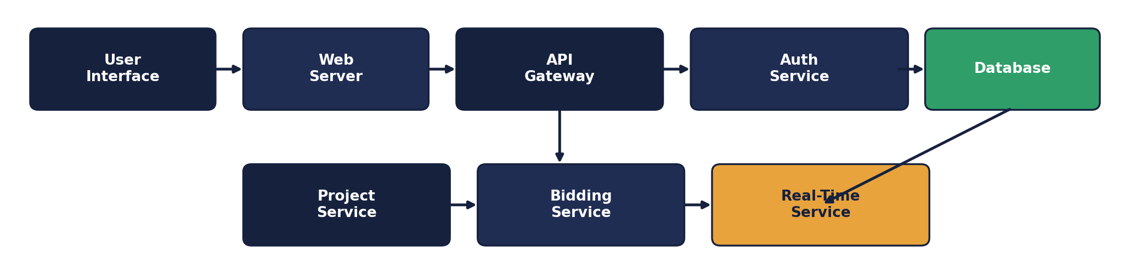

Technical Architecture Overview
Our freelance marketplace platform is built on a robust, scalable architecture designed to deliver a trustworthy and seamless user experience.
User Interface (UI): A clean, role-aware interface lets clients post and manage projects while freelancers browse, bid, and track proposals.
Web Server: Hosts the UI and handles user requests, delivering dynamic, role-specific content with quick response times.
API Gateway: Acts as the central entry point for all client requests, managing communication between services.
Authentication Service: Secures user access through JWT-based authentication and role-based authorization.
Database: Stores user profiles, projects, bids, and reviews, enabling accurate matching and a transparent history for every engagement.
Project & Bidding Service: Manages project creation, browsing, bid submission, and bid acceptance.
Real-Time Service: Powers live chat and instant notifications via Socket.io, keeping both parties informed the moment something changes.
Together, these components create a powerful ecosystem that supports a transparent, responsive, and scalable freelance marketplace experience.

ER DIAGRAM:
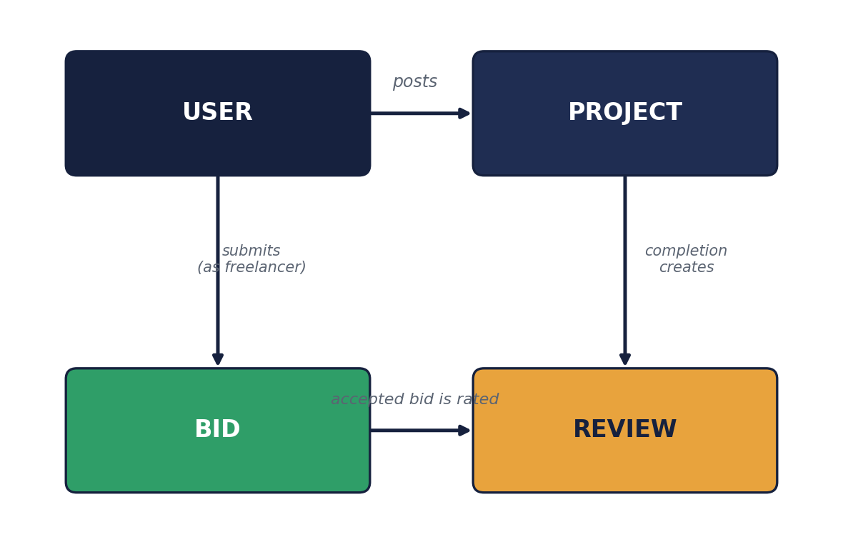

Entities and Relationships

1. User
- Represents clients and freelancers using the platform.
- Each user has a unique profile with details such as name, email, role, and verification status.
Relationships:
Posts → Project: A client posts projects that freelancers can discover and bid on.
Submits → Bid: A freelancer submits proposals to be considered for a project.

2. Project
- Tracks each posted project's requirements, budget, category, and current status.
Relationships:
Receives → Bid: Each project can receive multiple competing proposals.

3. Bid
- Represents an individual proposal submitted by a freelancer for a specific project.
Relationships:
Belongs to → Project: Each bid is tied to exactly one project.
Submitted by → User: Each bid is tied to the freelancer who submitted it.

4. Review
- Used to record feedback after a project is marked completed.
Relationships:
Generated from → Project: A review can only be left once a project is completed.
Rates → User: A review updates the reviewed user's average rating.

Key Features:

1. User Management
User Registration and Authentication: Allows users to register with a specific role, securely log in, and authenticate via JWT to access role-appropriate content.

2. Project Management
Project Listings: Displays a comprehensive, filterable catalog of open projects with details such as title, budget, category, and required skills.

3. Bidding, Communication and Trust
Bid Submission & Acceptance, Real-Time Chat, Reviews & Ratings: Tracks proposals from submission through acceptance, enables live conversation between parties, and records post-completion feedback to build trust over time.

ROLES AND RESPONSIBILITIES:
Client:-
Registration: Clients are responsible for creating an account on FreelanceHub by providing necessary details like name, email, and password.
Profile Management: Clients can manage their profile, including company name and description.
Project Posting: Clients can post new projects specifying title, description, budget, category, and required skills.
Reviewing Proposals: Clients can review incoming bids, shortlist freelancers, and accept the most suitable proposal.
Providing Feedback: Provide reviews and ratings for freelancers after a project is completed.
Logout: Finally, they can logout from FreelanceHub.

Freelancer:-
Registration: Freelancers create an account specifying their skills and experience.
Profile Management: Freelancers manage their profile, portfolio, and verification status.
Project Discovery: Freelancers can browse and filter open projects matching their skills.
Bid Submission: Freelancers can submit proposals with a price and message for projects they wish to work on.
Providing Feedback: Provide reviews and ratings for clients after a project is completed.
Logout: Finally, they can logout from FreelanceHub.

Admin:-
User Management: Admins are responsible for managing user accounts, including verifying, blocking, or deleting accounts as needed.
Project Management: Admins oversee all projects posted on the platform and can remove ones that violate policy.
Dispute Resolution: Admins review disputes raised by either party and resolve them fairly based on the evidence provided.
Verification Management: Admins review verification requests and approve or reject them.
Monitoring Progress: Admins monitor platform activity through analytics, tracking user growth, project volume, and completion rates.
User Support: Admins provide support to users who encounter issues while using the platform.
Reporting and Analytics: Admins generate reports on user engagement, project activity, and platform health to inform decisions.
App Maintenance and Updates: Admins oversee the maintenance of the app, including regular updates and improvements.

User Flow:
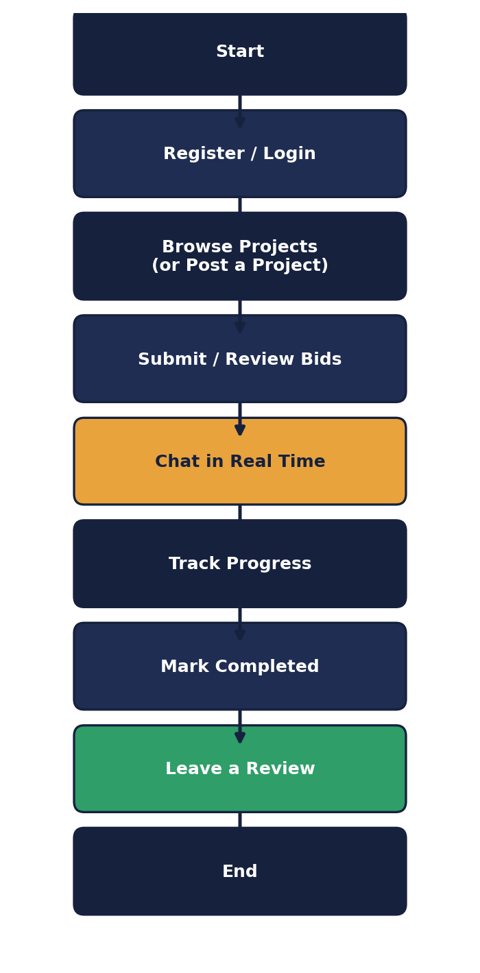
Start: The user opens FreelanceHub.
Register/Login: The user creates an account or logs into an existing one.
Browse/Post: A freelancer browses open projects, or a client posts a new one.
Bid/Review: A freelancer submits a bid; a client reviews and accepts a proposal.
Chat: Both parties communicate in real time about the project.
Track Progress: The project moves from open to in-progress as work continues.
Complete & Review: The client marks the project completed, and both sides leave a review.
End: The user logs out or exits FreelanceHub.

MVC PATTERN:
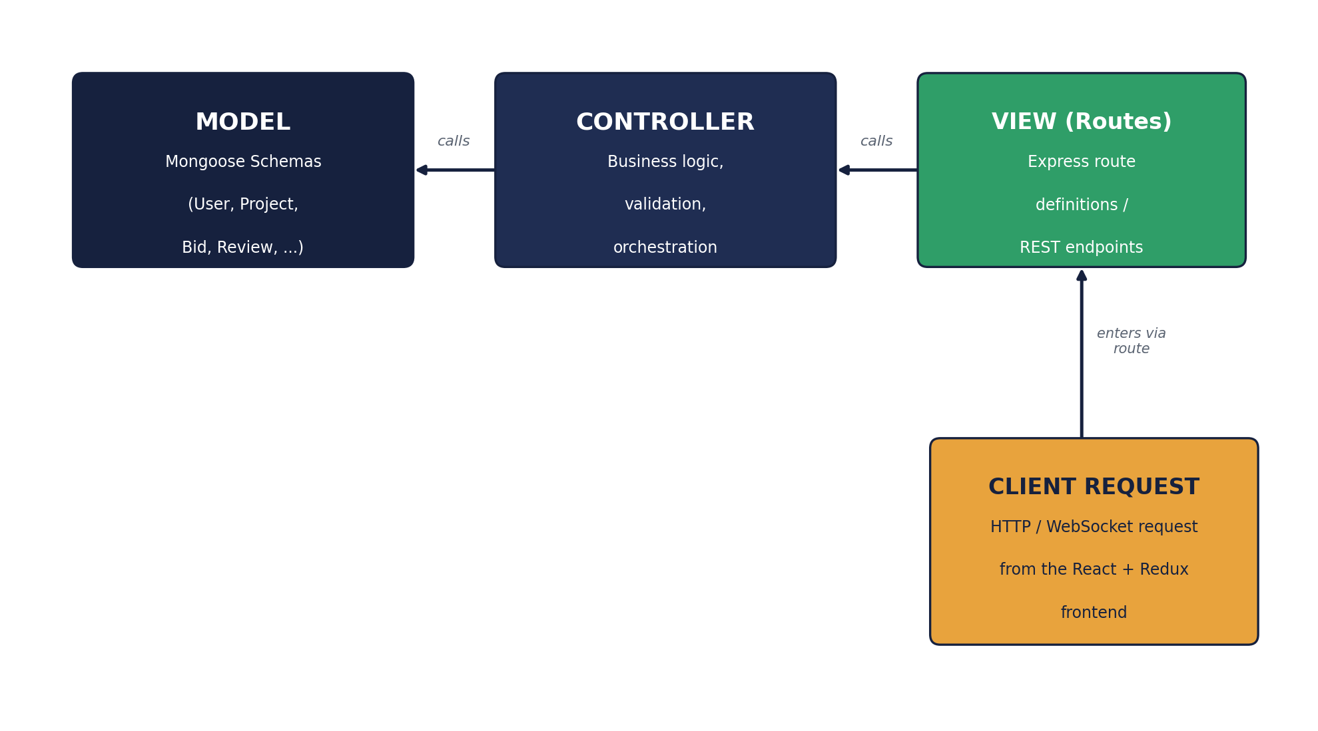
The FreelanceHub application follows the Model-View-Controller (MVC) architectural pattern, a software design approach that separates an application into three interconnected layers. This separation allows for modularity, easier maintenance, and scalability.
Model Layer (Data Layer)
The Model layer is responsible for handling all data-related logic. This includes the definition of data schemas (User, Project, Bid, Review, and more) and the operations performed on the database using those schemas. The models are implemented using Mongoose, which provides a schema-based solution to model application data for MongoDB.
Controller Layer
The Controller layer acts as an intermediary between the view (routes) and the model. It receives incoming requests, processes the input (which may include validation or transformation), calls the appropriate methods from the model, and then returns a response to the client.
View Layer (Routing Layer)
In the context of a backend REST API, the View is implemented as the routing layer, where various endpoints are defined. These endpoints determine how the backend responds to different HTTP requests (GET, POST, PUT, DELETE) and are responsible for invoking the appropriate controller functions.
Advantages of Using MVC in This Project
Separation of Concerns: Each layer has a clearly defined responsibility, improving readability and maintainability.
Scalability: New features can be added easily by creating new routes, controllers, and models.
Reusability: Logic in controllers and models can be reused across multiple parts of the application.
Testing: Each layer can be tested independently, especially the controllers and models.
Collaboration-Friendly: Multiple developers can work simultaneously on different layers without conflict.

Project Setup And Configuration.
Creating project folder
1. Create a new folder with your <project name>.
2. Inside that folder create two new folders.
3. Name one as backend.
4. Name another one as frontend.
5. Now open that folder in VS Code.
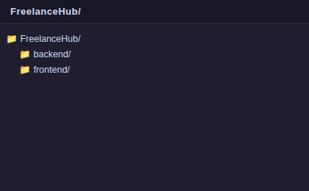
Frontend setup (installing React app via Vite)
- Open the frontend folder in the terminal of VS Code.
- npm create vite@latest . -- --template react
- Select React framework from the given options.
- Select JavaScript variant from the given options.
- To install all the packages run: npm install
- To start the React dev server: npm run dev
Backend setup (npm init)
- Open the backend folder in the terminal of VS Code.
- npm init -y
- Create files: server.js
- Create folders: config, models, controllers, middleware, routes, socket

BACKEND DEVELOPMENT:
Backend Structure:
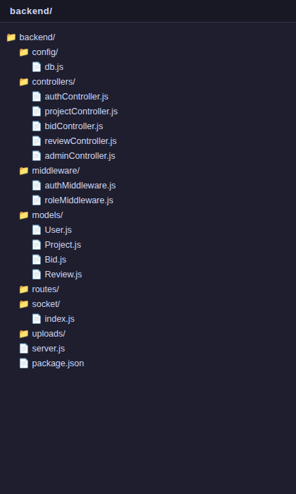
backend/
config/
db.js — Sets up and connects your backend to the database (MongoDB via Mongoose).
controllers/
- authController.js — Handles registration and login logic.
- projectController.js — Handles project creation, browsing, and CRUD.
- bidController.js — Handles bid submission, shortlisting, and acceptance.
- reviewController.js — Handles review submission and rating recalculation.
- adminController.js — Handles user/project management and analytics.
middleware/
- authMiddleware.js — Verifies JWT tokens and protects routes that require authentication.
- roleMiddleware.js — Restricts a route to specific user roles (client, freelancer, admin).
models/
User.js, Project.js, Bid.js, Review.js — Define the Mongoose schemas/models for each collection.
routes/
Route files map each REST endpoint to its corresponding controller function.
socket/
index.js — Sets up Socket.io for real-time chat and live notifications.
server.js —
Entry point of the backend; sets up the Express server, middleware, and routes.

DATABASE DEVELOPMENT:
1. Configure MongoDB:
- Install Mongoose.
In your Node.js project directory, run:
npm install mongoose
- Create database connection.
- Create Schemas & Models.
Create Database connection:
Now, make sure the database is connected before performing any actions through the backend. The connection code looks similar to the one provided below.
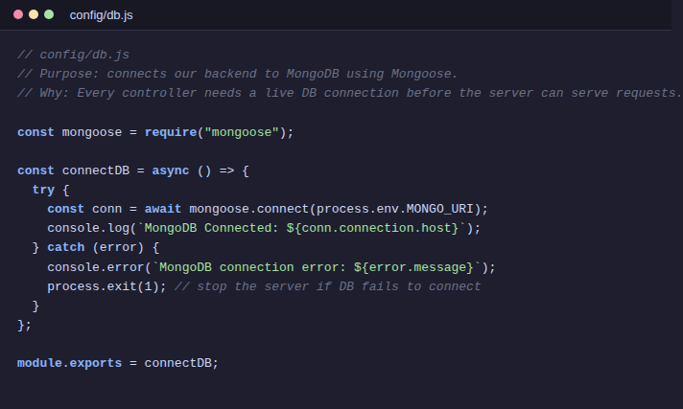
Create Schemas:
Firstly, configure the schemas for the MongoDB database to store data in a consistent structure. Use the entities from the ER diagram to create the schemas. The schemas for this application look similar to the ones provided below.
Bid.js — Defines the Mongoose schema/model for freelancer proposals stored in the database.
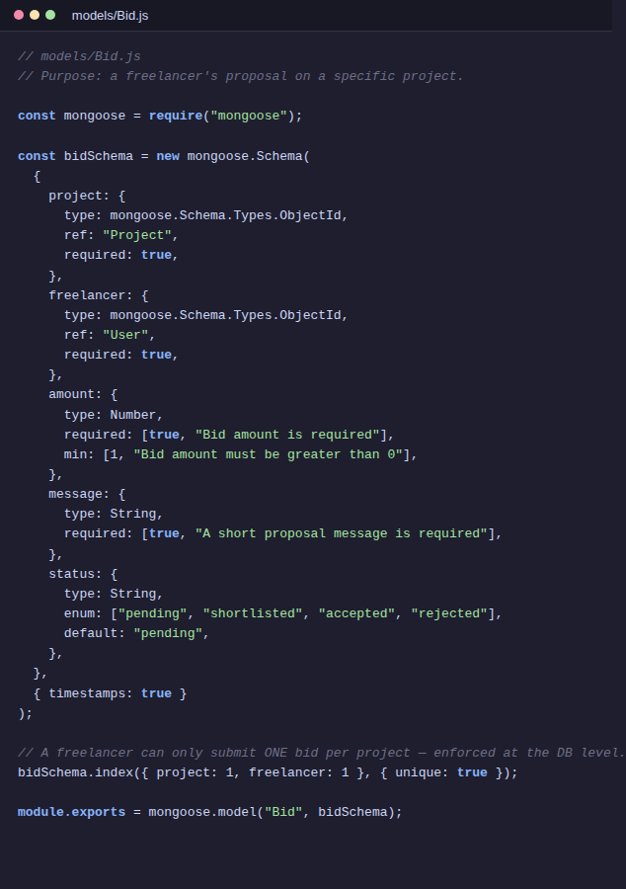
User.js — Defines the Mongoose schema/model for user accounts.
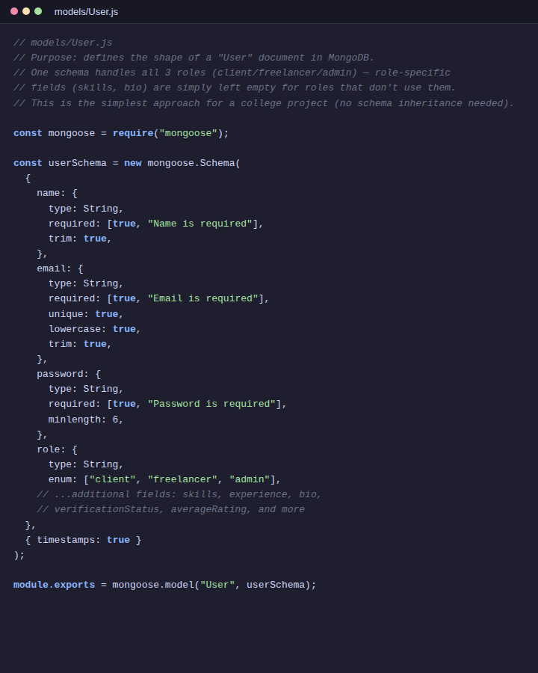

FRONT-END DEVELOPMENT:
Frontend Structure:
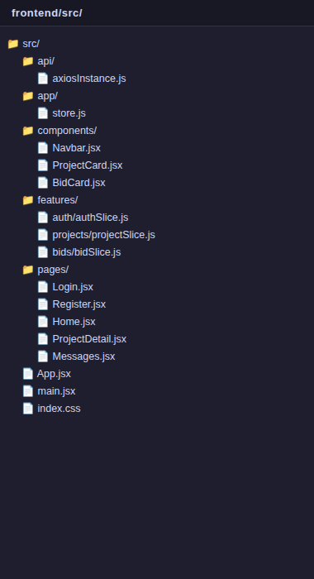
frontend/

src/
api/ — Axios instance configuration for calling the backend REST API.
app/ — Redux store configuration.
components/ — Reusable UI components (Navbar, ProjectCard, BidCard, LoadingSpinner, etc.).
features/ — Redux Toolkit slices, one per domain (auth, projects, bids, reviews, admin, chat, notifications).
pages/ — Route-level pages (Login, Register, Home, ProjectDetail, Messages, AdminDashboard, etc.).

Root Files/
App.jsx — Main component that holds all routes and the global layout.
main.jsx — Entry point that renders the App component into the DOM.
index.css — Global design tokens and Bootstrap style overrides.

Output ScreenShots:
My Projects (Client Dashboard):
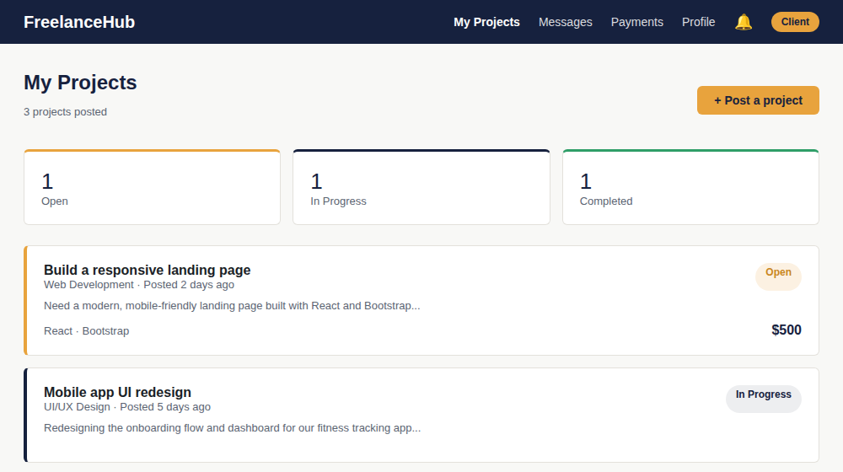
Signup Page:
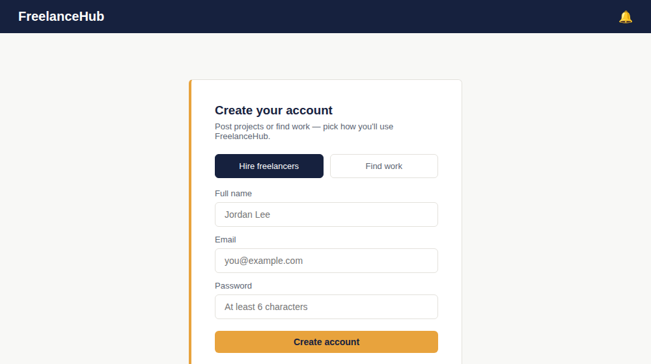
Login Page:
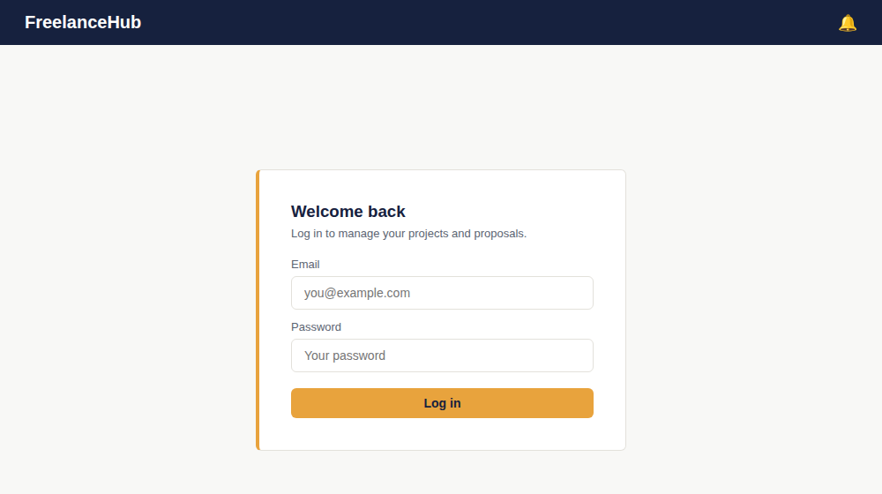
Browse Projects (Freelancer):
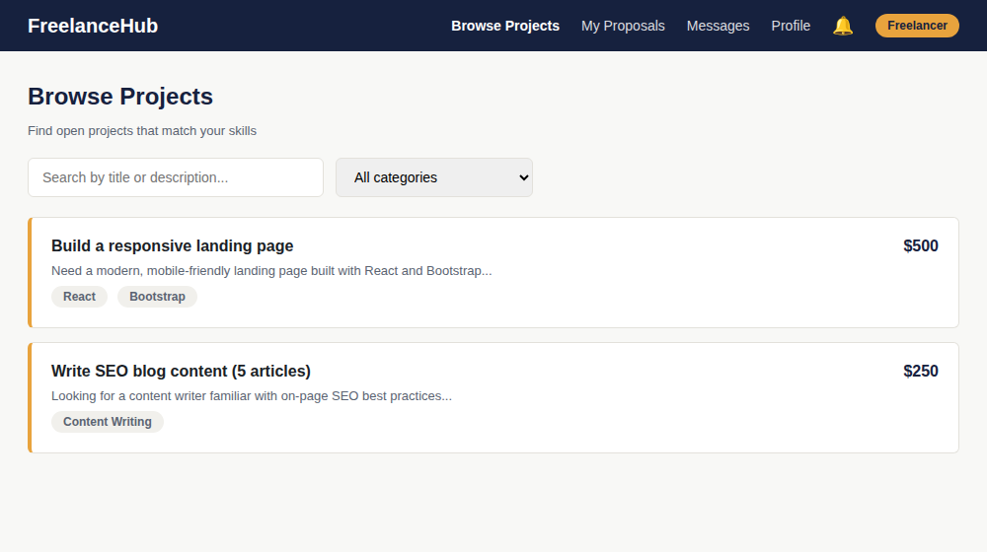
Project Detail & Proposals:
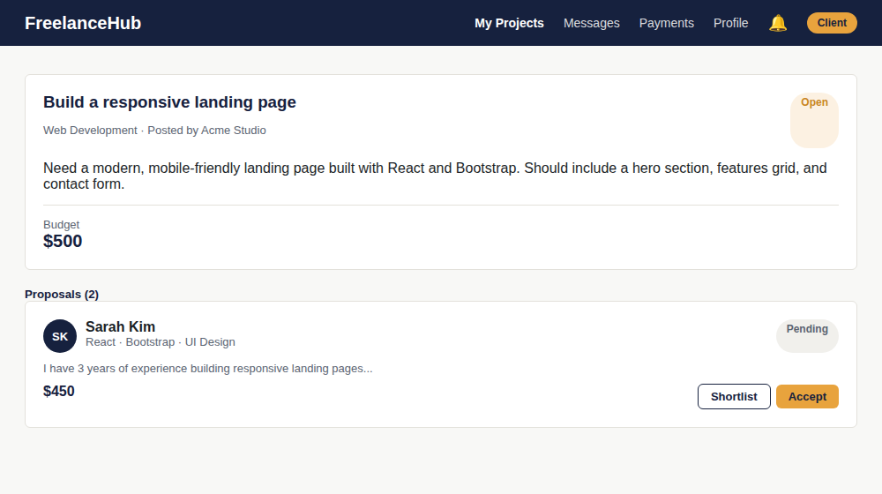
Messages (Real-Time Chat):
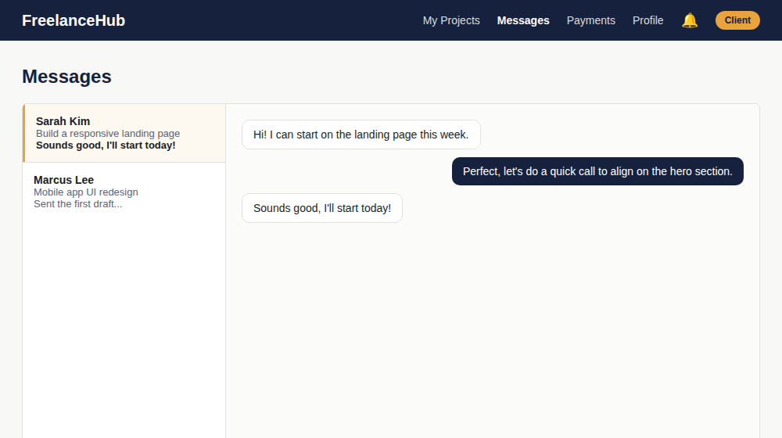
Admin Dashboard:
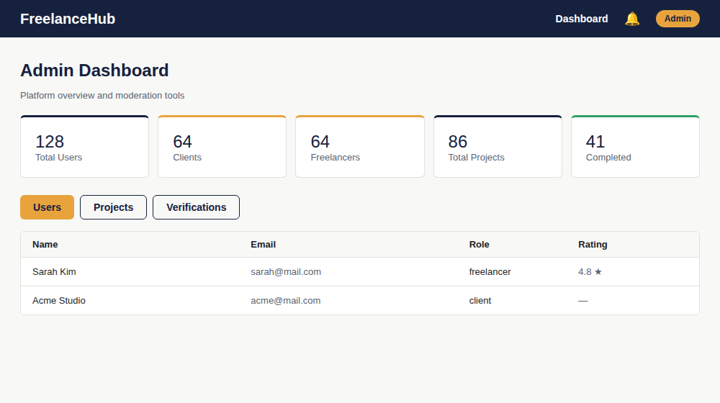
Profile Page:
